|  |  |  |  |  |  |  |
| --- | --- | --- | --- | --- | --- | --- |
| **Mehran University of Engineering & Technology,**  **Jamshoro** | |  | **Subject** | | | |
| **Web Technology** | | | |
| **Department of:**  **Bachelor of Science Computer Science** | | **Year** | **2nd** | **Semester** | **3rd** |
| **Roll No:** | **20BSCS043** | **Batch** | **20BSCS** | **Duration** | **3 Hours** |

**PRACTICAL # 8**

**TO DEVELOP DHTML BASED WEBPAGES**

**Task # 1:** Make a webpage, generate alert box when user setFocus on an input box

**Code:**

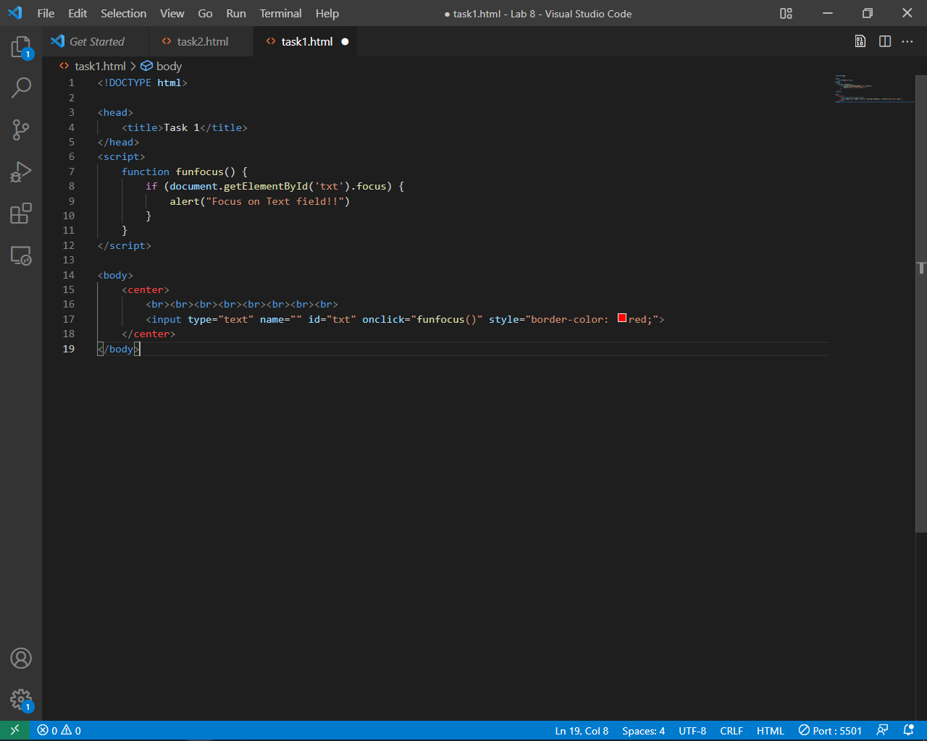

**Output:**

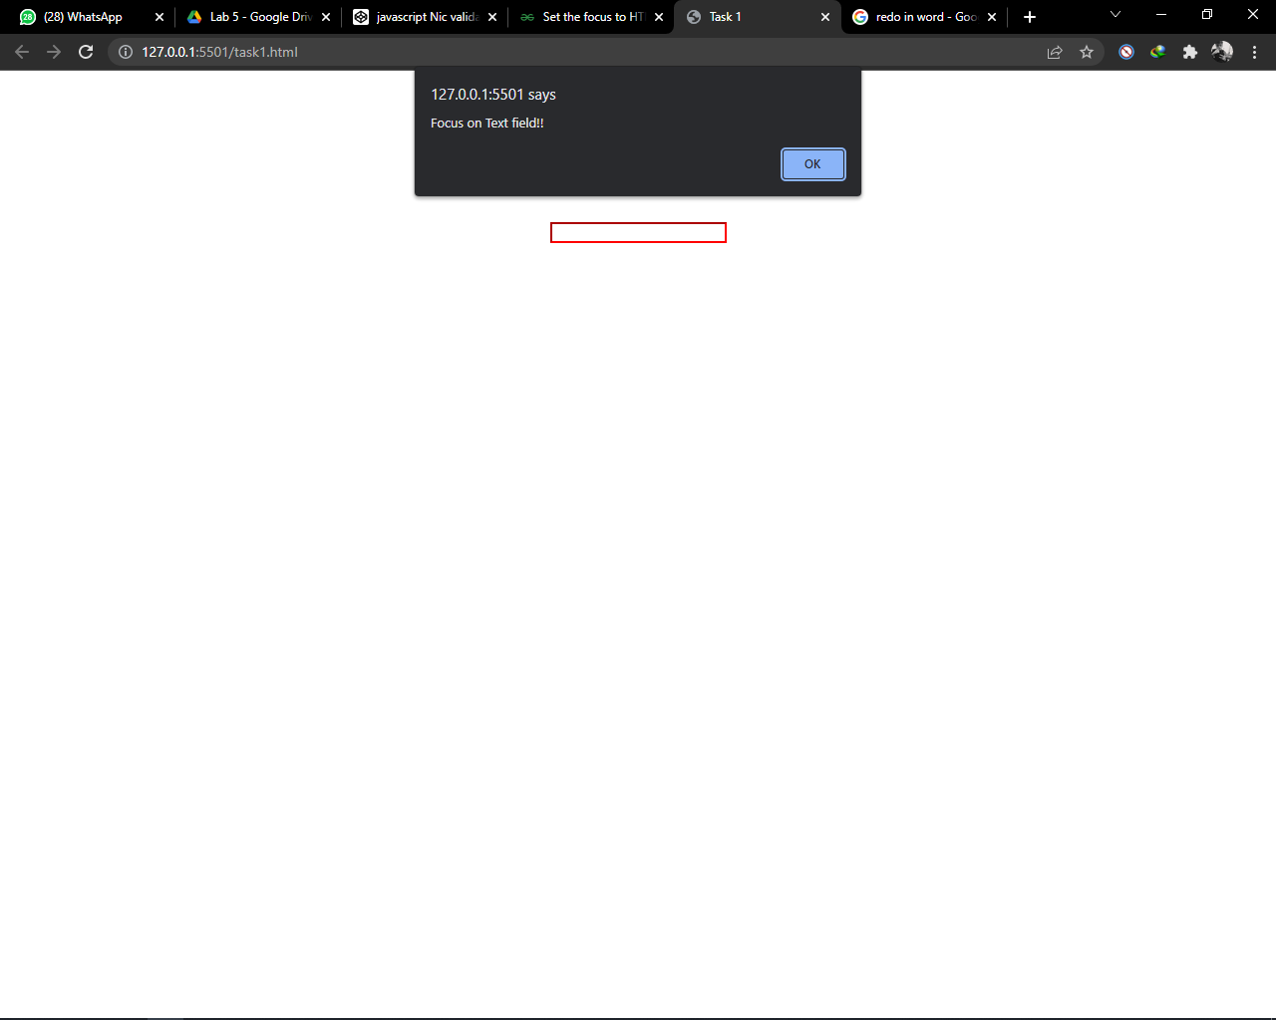

**Task # 2:** : Make a webpage having a single button. If, user clicks 1st time on button then background color of the page should be changed as sky blue, when user press 2nd time on button then background color of the page color should be changed to orange color/any other color of your choice.

**Code:**

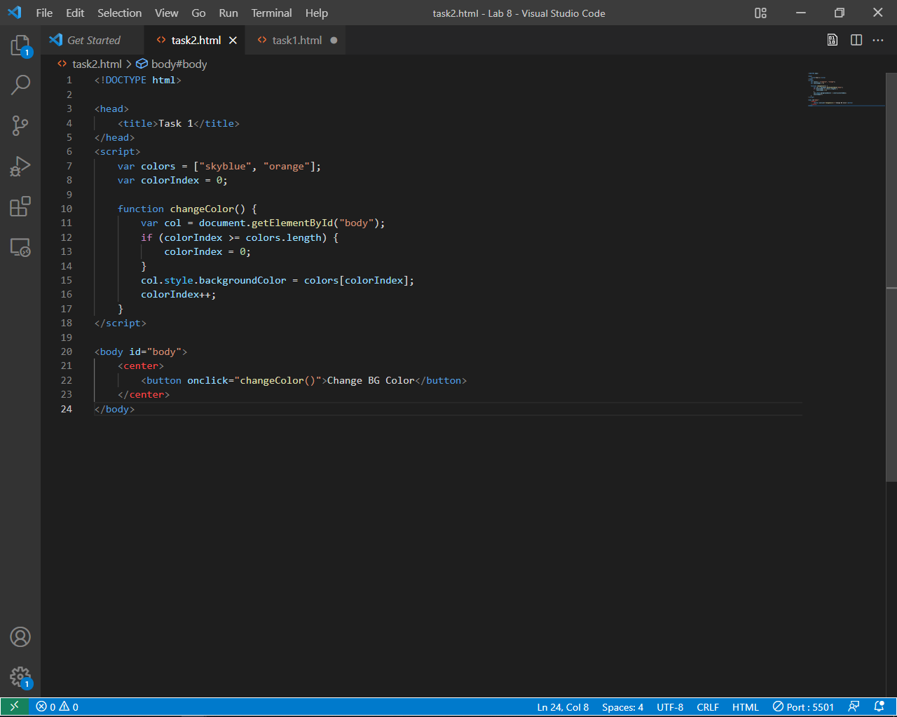

**Output:**

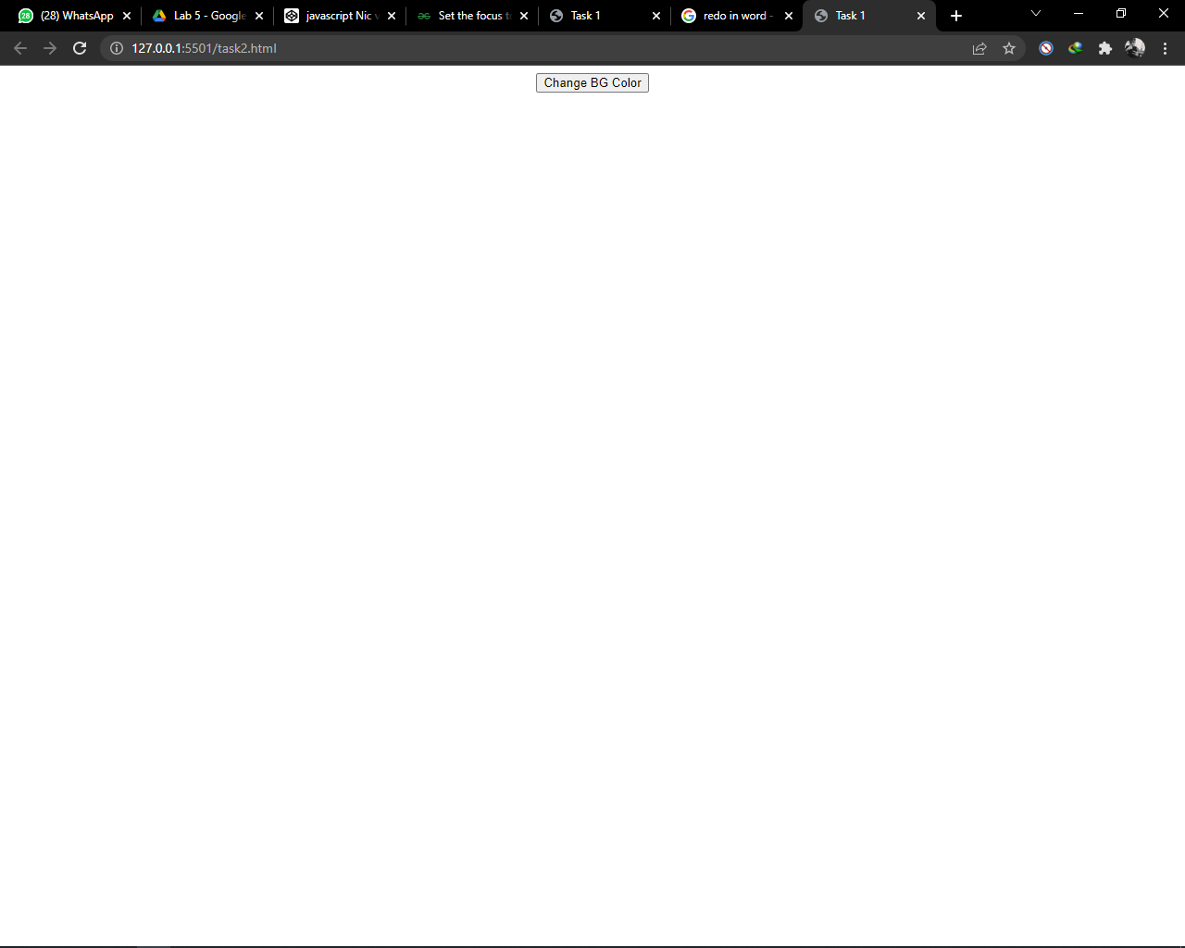

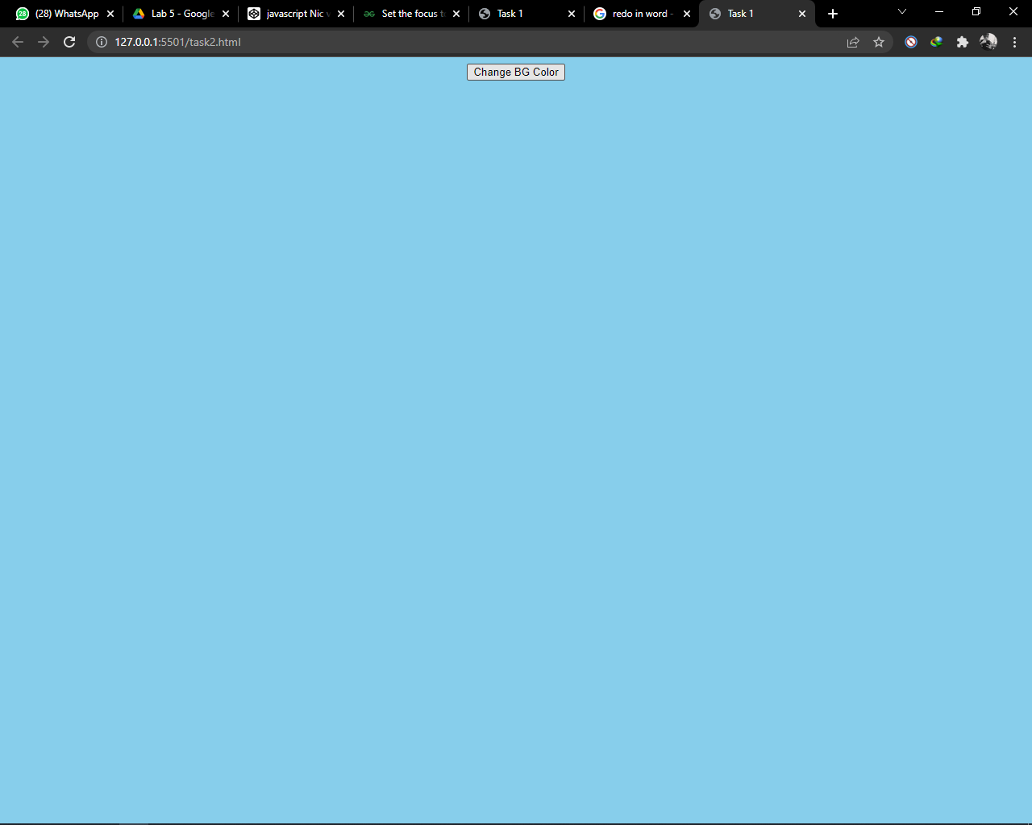

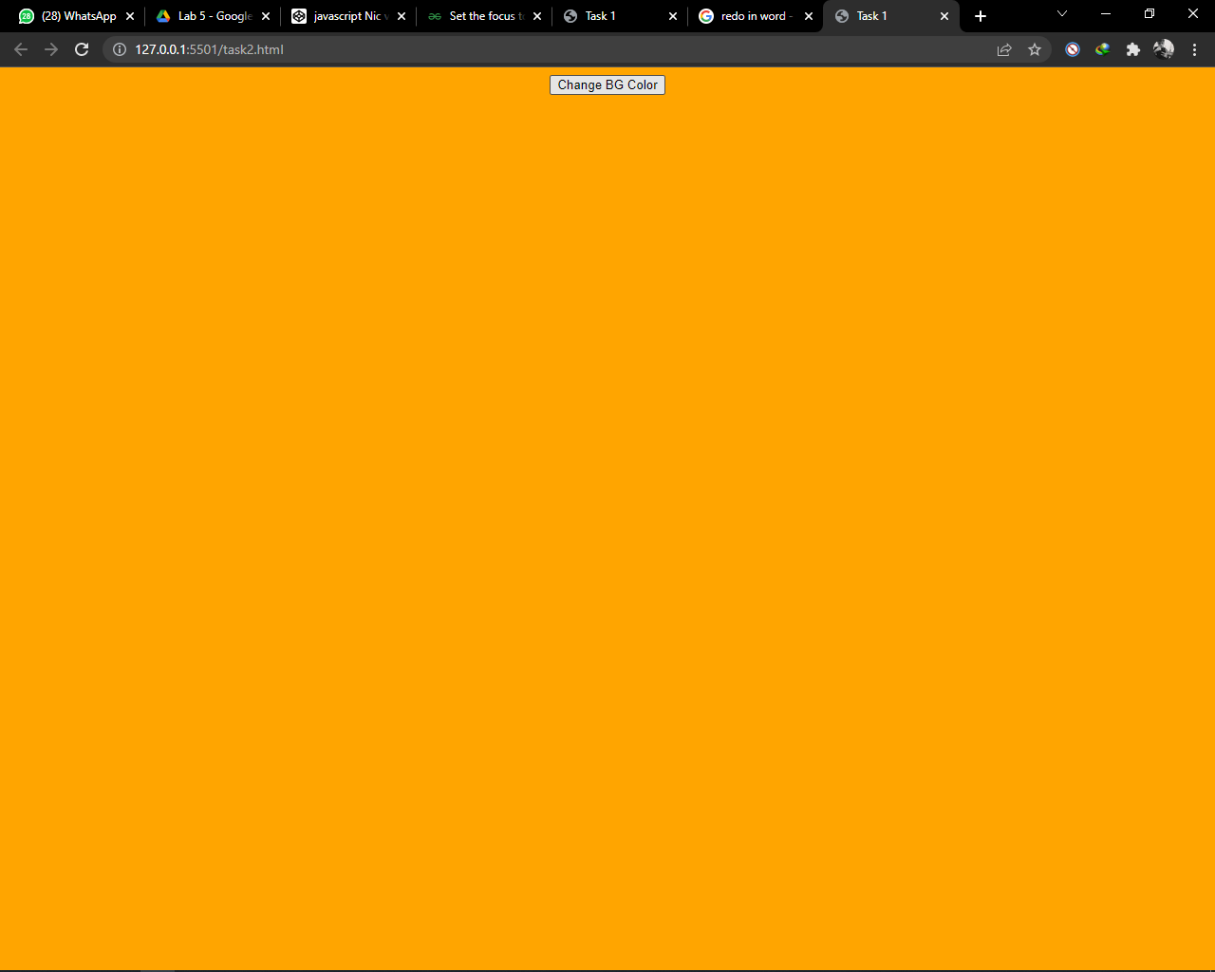

**Task #3:** Create a calculator in JavaScript by using the functions including with some styles (e.g.; Background color, font size, borders etc.)

**Code:**

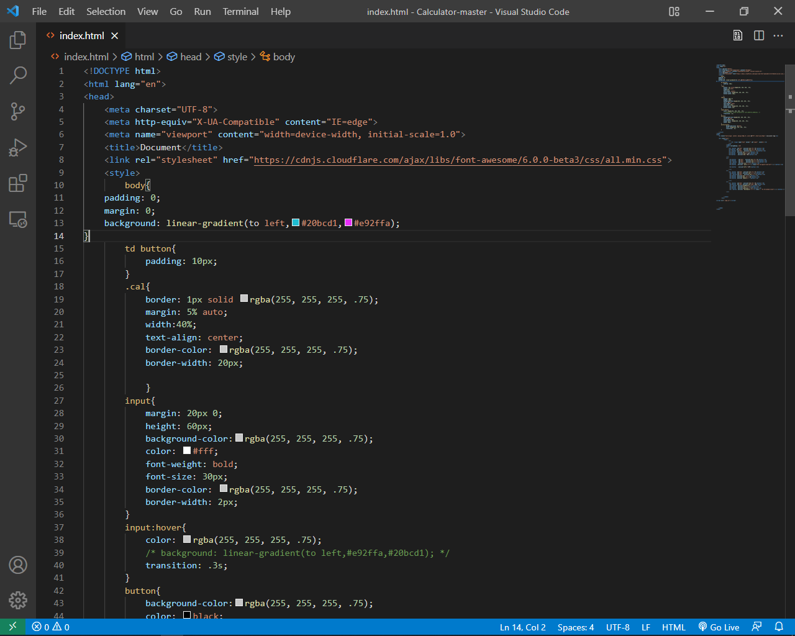

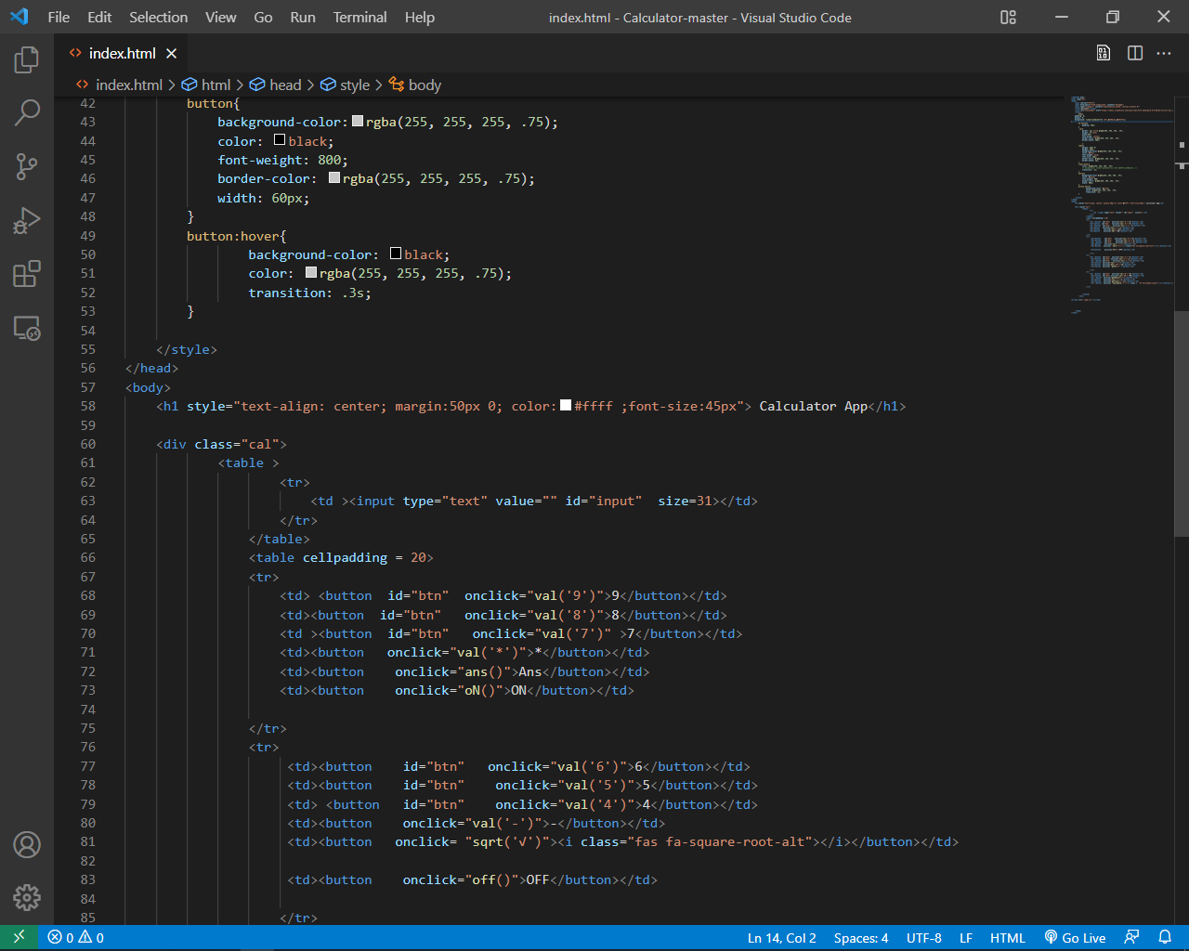

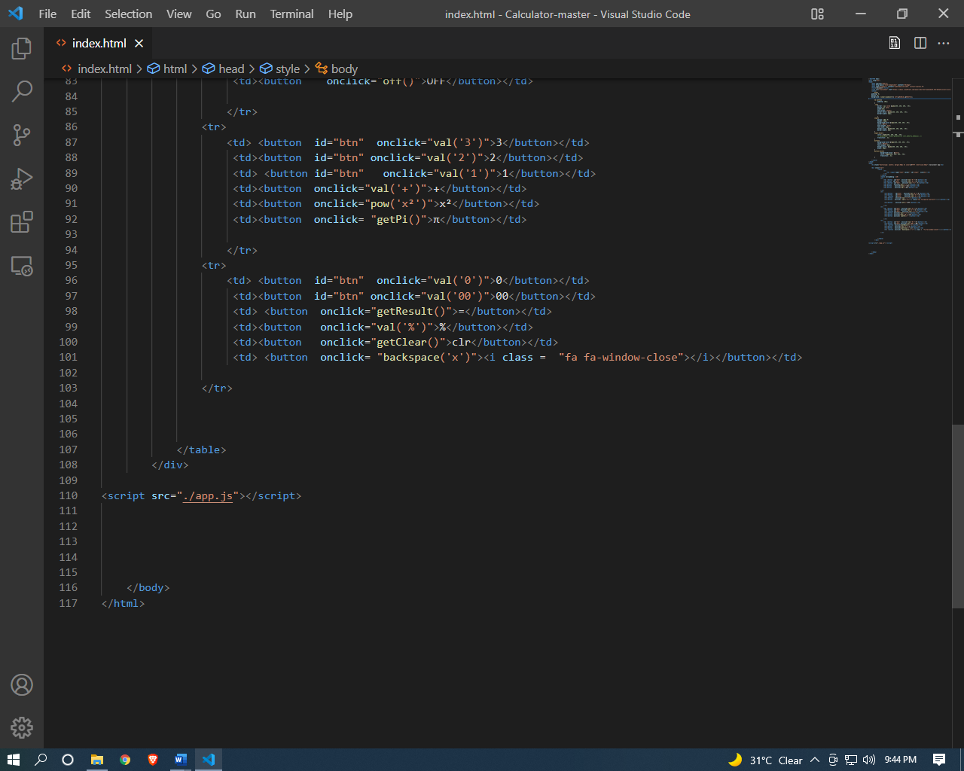

**Output:**

